Kol Simcha Torah Gazette
For parshas toldos 5786
Vol 10 Issue 8 (Whole #473) 2 Kislev 5786/ November 22, 2025
Printed L’illuy nishmas Nechama bas R’ Noach, a”h
For a free subscription, please forward your request to keren18@juno.com
Past emails can be found on the website ShabbosStories.com under Brooklyn Torah Gazette

The Inspiring Story from a Terrible Jewish Tragedy
By Daniel Keren

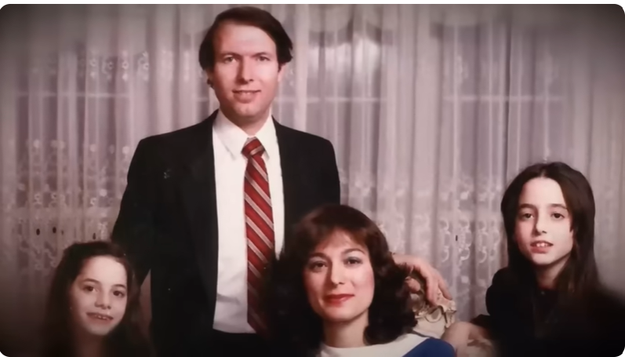
The Greenwald family, Yisrael Asher Greenwald, hy”d; with his wife and two daughters.

One of the most fascinating Meaningful People podcasts was “The Shocking Story the FBI Tried to Bury” a recent episode in which Nachi Gordon interviewed Michal Weinstein who recalled the terrible tragedy that struck her family on that Monday, February 10, 1985.
On that day Michal was outside her house in Far Rockaway, NY waiting for the bus to take her to school. Her father Yisrael Asher Greenwald, a 34-year-old diamond dealer with an Israeli diplomatic passport was going to his car to go to work. Suddenly he went from his car and walked over to Michal and put his arm around her and gave her a strong hug. Then he went to his car and went to work. Only he never returned home that night or ever again.
Life was drastically changed overnight and multiple difficulties overwhelmed Michal and her mother and younger sister Lisa. Up until the disappearance of her father, the family enjoyed a very comfortable life due to her father’s success as a diamond dealer who traveled around the world, but always made a point to always be home with his family for Shabbos.
Michal’s parents were born in Israel, the children of Holocaust survivors. Prior to her father’s disappearance was her greatest shame at her parent’s heavy Israeli accents. But she also recalled the wonderful vacations the family were able to enjoy including Pesach at nice hotels when her father was around.
When her father disappeared, rumors in the Far Rockaway community broke out. Some thought perhaps her father was involved in Mafia activities. Michal’s mother did extensive sleuthing of her own, but was greatly frustrated over what she felt was the FBI’s failure to pursue the case, indeed as the title of the podcast declares – “The Shocking Story the FBI Tried to Bury.”
While the FBI and her mother believed that Michal’s father had been killed by Mafia criminals belonging to the Lucchese and Gambino crime families, since there was no found body, the family was unable to claim either a life insurance settlement or social security benefits. As a result, Michal had to endure the humiliation of looking through the windows of her house as the family’s car was repossessed and later being forced to move out of the family house in Far Rockaway because of a foreclosure due to her mother’s inability to keep up on the mortgage payments.
It was only recently that Michal learned that members of the community came together to raise money to help the Weinsteins keep the house. Unfortunately, the man who was collecting the money from others in the community stole the money and the house was foreclosed and the family evicted.
For 19 years, Michal endured the humiliation until the day that the FBI came and told her mother that they had arrested two rogue NYPD cops for the murder of her husband and that as a result of their investigation they had uncovered the remains of Michal’s father.
That revelation was the turning point and many inspiring events erupted in her life. Perhaps one example was her speech before the court at the sentencing of the corrupt cops who worked with the Mafia and killed her father. She said to the cops that they forgot one thing. They thought they could get away with their crime, but Michal declared that her father’s killers forgot one important point – the power of the prayers of their victim’s daughter’s asking G-d for justice. And justice was achieved – both rogue cops were convicted and sentenced to life in jail without parole. And they did die in jail – one in 2017 and the second in 2019.
Michal Weinstein wrote of her thoughts in the aftermath of her father’s disappearance and eventual discovery and we can only hope that she puts it together into an inspiring book with the help of a good editor. To enjoy this well-done podcast, you can google either “The Shocking Story the FBI Tried to Bury” or https://youtu.be/lmCV1_rN9-I?si=rqrwlnr7H5gsN6HE

Reprinted from the November 14-21 edition of The Jewish Connection.

Thoughts that Count for Our Parsha

And one people shall be stronger than the other (Gen. 25:23)
Rashi comments: When one rises, the other falls. Jacob and Esau symbolize the struggle between the G-dly soul and the animal soul, between a person's good and evil inclinations. When a Jew's G-dly soul is dominant and exerts itself, there is no need to combat the animal soul - it "falls" by itself. Light does not have to fight darkness to illuminate - as soon as it appears, the darkness vanishes. So too, does the light of holiness dispel all evil. (Sefer Hamaamarim)

Sojourn in this land, and I will be with you (Gen. 26:3)
The Torah uses the word "sojourn" instead of "dwell" to teach us that one must always consider oneself a temporary resident of this world. "The Shechina (G-dly presence) does not move away from one who considers himself a stranger in this world," we are taught. The second part of G-d's promise, "I will be with you," will be fulfilled when Jacob thinks of himself in this manner. (Vayechakem Shlomo)

And they departed from him in peace (Gen. 26:31)
Even after having partaken of a meal with the tzadik, Isaac, Avimelech still departed convinced of his own self-importance. This is something that a Jew would have been unable to do. A Jew, when in the presence of a tzadik, realizes his own shortcomings and is humbled. (Reb Bunim)

Reprinted from the Parashat Toldos 5763/2002 edition of L’Chaim

Rav Avigdor Miller
On Accepting Money

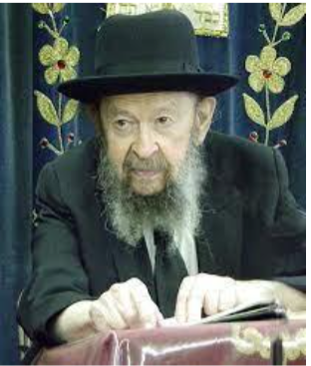

QUESTION: If wealth can be dangerous should I refrain from asking for a raise?
ANSWER: You could ask a better question. Should I refrain from taking any money home? At the end of the week when my boss gives me the envelope I should say, “Nothing doing”.
And the answer is a raise is not wealth yet. You’ll need that raise because the landowner will give a raise anyhow. Next week you go to the grocery store, bread costs 10 cents a loaf more. So, you’ll need that money.
And I’ll tell you even more. If suddenly you get a long-distance call from an uncle in South Africa and he says, “I’m putting you in my will for $100,000,” don’t protest. When Hakadosh Baruch Hu gives you life, you shouldn’t protest against life. Life is an opportunity to do a lot of mitzvos.
Although a great many people would be lucky if they died when they were young. Even now we can point out a great many people who would do not only a great service to the world if they died right now but a service to themselves. And still nobody should perform that service because Hakadosh Baruch Hu wants you to try anyhow. ועל כרחך אתה נולד – You were born against your will (Avos 4:22), and Hashem said, “I’m not asking you if you want to be born. Make use of the life I’m giving you and do a good job.”
And wealth is also conferred upon you without asking your permission. And when they were going out of Egypt, Hakadosh Baruch Hu said they should take along with them all they could. And Moshe Rabeinu was loathe, he was unwilling to do that because he was afraid of wealth. So Hakadosh Baruch Hu said “B’bakashah, I’m begging of you.” You hear that? “I’m begging of you. Go to the Bnei Yisrael ve’emor lahem, and say to them, bebakashah, because I am begging of you take along silver and gold.”
They didn’t want silver and gold. They were afraid of it. But Moshe said, “I’m begging of you.” It means they had to do it anyhow, whether they wanted it or not. “I’m begging please take silver and gold with you.”

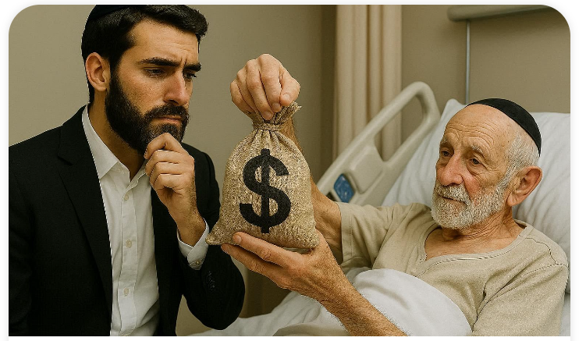

Hakadosh Baruch Hu wants you to be tested with silver and gold. And the uncle is testing you if you’re able to take $100,000 or $1 million and still remain, let’s say, in Flatbush, in the Jewish neighborhoods, and go to synagogue every day and be a decent person and of course give away from your money to charity too. It’s a great test. If a person passes successfully the test of wealth, it’s like Noach who was successful bador hazeh – even in that generation of happiness and great success, Noach still remained a tzaddik before Hashem.
Every man is being tested if he’s given wealth to see how he’ll behave even under the difficulties of wealth. So don’t refuse if your lawyer calls you up and says, “Your rich uncle has left a will and you were mentioned there for a million dollars.” Don’t protest.

Reprinted from a recent email of Torah Avigdor based on a lecture delivered sometime in October 1982).

The Special Connection of
Our Patriarch Isaac
to the Messianic Era
From the Teachings of the Lubavitcher Rebbe
Rabbi Menachem Mendel Schneerson, Zt”l


This week's Torah portion, Toldot, describes the life of our Patriarch Isaac. The Talmud teaches that in the Messianic Era, Isaac will be referred to as "our father," implying that it is Isaac from among our Patriarchs who has a special connection to the Messianic Era. As we now stand at the threshold of the Redemption of the Jewish people, it is important to understand what exactly Isaac's path and service mean for us.
Isaac was the only one of our Patriarchs who lived his entire life in the Land of Israel. Abraham was born outside of Israel and also left Israel to go to Egypt when a famine threatened. Jacob, too, left Israel to work for Laban.
However, when there was another famine in the Land during Isaac's lifetime, G-d commanded him to stay where he was and not to seek food elsewhere. "Do not go down to Egypt, but dwell in this land...and I will bless you." This is because after having shown his willingness to be sacrificed on the altar by his father Abraham, Isaac was considered a "perfect offering," too holy to dwell anywhere but in the Holy Land.
Isaac, therefore, symbolizes the Jewish people as they were meant to be, and as they will exist in the Messianic Era, their rightful place being in their land and not in exile in the four corners of the earth. During our present exile, we are like "children who have been banished from their father's table." We must therefore continue to demand that G-d send the redeemer now, so that we will be able to emulate Isaac and live a full life of Torah and mitzvot in our own land, as we were meant to.
Isaac's approach to the service of G-d is also especially applicable to us today. Even though Isaac continued in his father Abraham's path of spreading the belief in G-d throughout the world, he did so in a different manner from his father: Abraham wandered from place to place, including Egypt, spreading G-dliness wherever he went. Isaac, on the other hand, always remained in the same place, in Israel, yet others flocked to him because they were attracted by his holiness. In this way Isaac was able to influence others.
For the most part, the Jewish people have followed Abraham's example during their long exile, wandering from country to country and causing G-d's name to be called on wherever they went. After Moshiach comes, however, we will follow in Isaac's footsteps, as G-d's holiness and light will emanate from the Third Holy Temple in Jerusalem. And at that time, as happened in the days of Isaac, all the nations of the world will likewise flock to Jerusalem, as it states, "And all nations shall flow unto it...for the Torah shall go forth out of Zion."
We must, in the meantime, combine aspects of both these approaches, refining our own personal spirituality, yet at the same time, not neglecting to spread holiness throughout the world at large.

Reprinted from the Parashat Toldos 5763/2002 edition of L’Chaim, a publication of the Lubavitch Youth Organization. Adapted from the works of the Lubavitcher.

And one people shall be stronger
than the other (Gen. 25:23)
Rashi comments: When one rises, the other falls. Jacob and Esau symbolize the struggle between the G-dly soul and the animal soul, between a person's good and evil inclinations. When a Jew's G-dly soul is dominant and exerts itself, there is no need to combat the animal soul - it "falls" by itself. Light does not have to fight darkness to illuminate - as soon as it appears, the darkness vanishes. So too, does the light of holiness dispel all evil. (Sefer Hamaamarim)

Reprinted from the Parashat Toldos 5763/2002 edition of L’Chaim
Ariel Berkowitz Was Run Over by a Train and Pronounced Clinically Dead
By Sarah Pachter

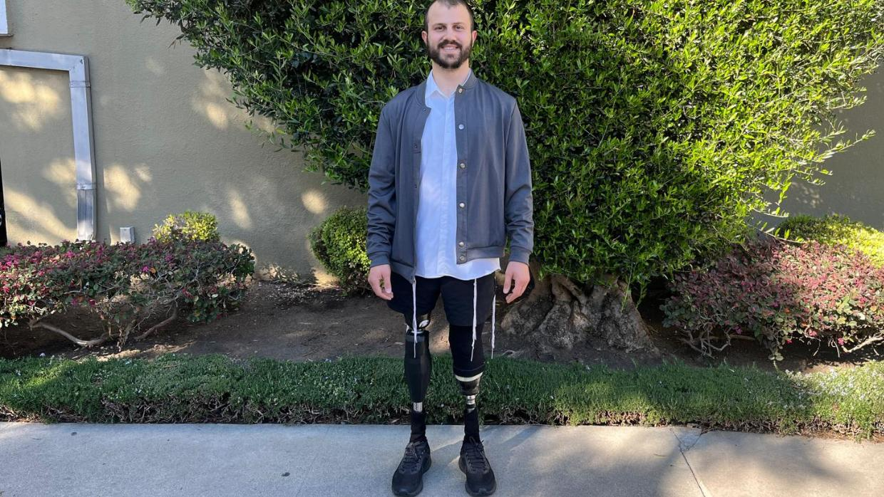

One moment, Ariel Berkowitz was stumbling through the streets of downtown Dallas—disoriented, lost, and unaware that his life was about to end. The next, he was lying lifeless on train tracks, his body crushed beneath the weight of a speeding DART train. Pronounced clinically dead, Ariel’s story should have ended there. But what happened next would defy science, awaken his soul, and transform his understanding of life, death, and divine purpose.
Ariel Berkowitz grew up in Dallas, Texas. His family was observant and he attended an Orthodox Jewish School. After the fourth grade, his parents shifted paths and sent him to public school. “All of a sudden, we were in the Taco Bell drive-thru, eating non-kosher food, and we stopped keeping Shabbat.”
It was confusing but Ariel went along with it. He started playing football and with his talent on the field, his popularity skyrocketed.
But by 9th grade, he was influenced by underage drinking and drugs. Shabbat was a distant memory, and so was G-d. “I hadn’t thought about anything Jewish in ages.”
Ariel started partying more, trying to fit in, and his grades slipped. He also stopped playing football.

Losing His Way
After high school, Ariel had no plan. He decided to move to Austin, Texas, where many of his friends lived. It was a lively, party-oriented city and he figured he could take a few classes while enjoying the scene. To cover his expenses, he took a job as a valet, but things didn’t go as planned. Before long, he stopped taking classes altogether and found himself spending money and wasting time. When his funds finally ran out, he had no choice but to move back to Dallas—with no job, no plan, and no source of income.

The Night of the Accident
Ariel was invited to a concert by a childhood friend. He didn’t want to go but felt indebted to his friend for helping him move.
“I’m not really a concert guy, and I was worried about losing my phone, as I’d heard many people do,” he recalled.
Before heading to the concert, he and his friends decided to drink alcohol and smoke marijuana. By the time they arrived, the night was already a blur. Ariel vaguely remembers a foggy haze with people jumping up and down like zombies. Then, his worst fear came true—he lost his phone. Agitated and frustrated, he decided to leave the venue.
“I just started walking and stumbled into downtown Dallas. I couldn’t find a ride, so I decided to just start walking home. Unfortunately, in the state of mind I was in, I didn’t realize how far home really was. I ended up coming across the light rail system that runs through Dallas. While walking across the tracks, I fell, hit my head on the hard concrete, and lost consciousness. My body was lying directly over the tracks.
“The DART train approached. Although the conductor tried to stop, it was too late—the train ran me over, dragging my body 90 feet and amputating my legs.”
Fortuitously, Baylor University Hospital was right across the street. First responders transported him there immediately.

Clinically Dead
In the hospital, Ariel was pronounced clinically dead—no heartbeat, no breathing, no brain activity.
The last thing he remembered was stumbling through downtown. The next moment, he found himself in a hospital room, drifting above his own body.
“I was drifting above myself—formless, just existing. Everything I ever loved or hated came together in one ball of energy. I was stuck above my body, connected by what felt like a spiritual umbilical cord.”
Many people describe near-death experiences as peaceful and filled with love—but Ariel’s was different. “I felt a deep sense of disappointment, like I had accomplished nothing in my life. I was also aware of everything happening in the hospital room.”
He watched as someone gently cleaned the blood from his hands. His friend who had taken him to the concert walked in, saw his body, and quietly wept. His parents and siblings couldn’t bring themselves to enter, too distraught over whether he would survive—or if he did, whether he would ever recover.
Only his grandmother was brave enough to step inside. She sat by his bed, opened a small book, and began to pray. Ariel somehow knew she had opened a book of Psalms. “Though I had known nothing about King David or his Psalms, I somehow knew what she was doing.”
Years later, Ariel would learn in his Jewish studies that when a soul leaves the body, it perceives truths it cannot grasp while confined within it.
“She closed the book and placed it under my pillow—and at that exact moment, I clicked back into my body.
“I know ‘click’ is a strange term to use, but let me explain,” he said. “It was like turning on a light switch. You feel a bit of resistance, and then suddenly—click—the light turns on. That’s what it felt like when my body and soul reconnected. It was a perfect fit, like slipping into a tailor-made garment.”
When Ariel woke up, a tube was down his throat. He felt a strange sensation in his lower body and knew something was wrong. Unable to speak, he motioned to write a single question: “Do I still have the ability to have kids?” Despite everything, his first concern was for his legacy and continuity.

Recovery and Awakening
When Ariel regained consciousness, his family gently broke the news—he had been in a terrible accident and both of his legs were gone. Though most people would have been devastated, Ariel felt overwhelming gratitude just to be alive. Few survive being run over by a train, yet his brain, hands, and back were miraculously intact. Surrounded by his family’s love, he resolved to stay strong for them.
Ariel understood that when the body fails, something far greater endures. There is more to existence than the physical world. This realization gave him a new perspective on life and relationships—and he refused to allow sadness over his limbs to define him.
Amazingly, Ariel was released from the hospital after only a week—an almost unheard-of recovery given his injuries. One leg had been amputated above the knee, the other below.
Determined to rebuild his life, Ariel received his first pair of prosthetic legs in May 2017. They were heavy and awkward but he began physical therapy and learned to walk again. He returned to school, earned enough credits to transfer to a university, and majored in biology. With a specially equipped car featuring hand controls, he regained his independence—and by the fall of 2019, Ariel was driving to class completely on his own.

Finding Purpose
In 2019, the father of Ariel’s concert friend passed away. To honor his memory, Ariel’s friend began attending synagogue three times a day and soon developed a deep interest in Judaism. He started keeping Shabbat and invited Ariel to join him. Ariel went simply to be supportive—but before long, he found himself genuinely drawn in.
The two began studying Me’am Loez, a classic Torah commentary translated by Aryeh Kaplan. Though the material was complex and far beyond his initial understanding, Ariel immediately recognized its truth and depth.
He started learning Torah weekly and gradually began keeping Shabbat himself—testing it by refraining from touching his phone for an entire day. “By the end of that day, I felt so uplifted that I didn’t even want my phone,” he recalls.
Week by week, Ariel’s commitment deepened. He began praying daily, studying regularly, putting on tefillin, and attending synagogue. “For the first time, I could say, ‘This is who I am.’”
He acknowledges that his growth is ongoing. “I’m not perfect,” he says, “but it’s about progress, not perfection.”

Finding Love and Purpose
Ariel knew he wanted to get married and dreamed of finding a woman with strong Jewish values. When he turned to matchmakers, many suggested women with disabilities, implying that an able-bodied girl might not be interested. None of those matches worked out.
After trying several dating apps with little success, Ariel decided to stop searching and surrender the process to a higher power. “I’m going to leave this to You, G-d,” he said.
In 2024, Ariel began working as a motivational speaker, sharing his story on podcasts across the country. Shortly after appearing on the Living L’Chaim podcast with Yaakov Langer, he was matched through the dating website Saw You at Sinai with a woman named Rebecca. After three months of dating, they got engaged and were married in March 2025. Ariel believes he found his soulmate in the merit of inspiring others through his story.

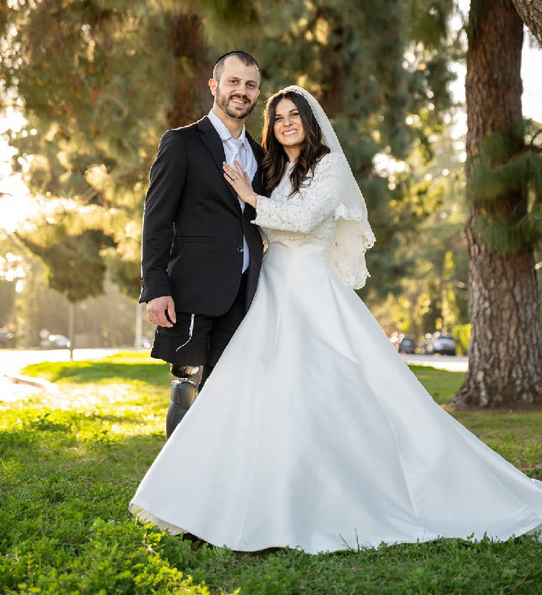

Ariel’s Message
When asked if he would go back in time and change anything—perhaps by avoiding that fateful concert—Ariel’s answer his answer is an unequivocal no.
“I wouldn’t change one thing that happened to me. I would rather have no legs and the connection I now have to G-d than have legs with no connection to Him and little to no sense of purpose. And I truly mean that. God showed me that there was a bigger purpose for my life.”

Reprinted from the current website of aish.com
Why Do We Bury
Jewish Books?
By Rabbi Yehuda Shurpin


Art by Sefira Lightstone

It’s a strange thing. We bury our loved ones once their bodies cease functioning. And Jews bury Torah books once they’ve lost their function. How did this come about?
After commanding us to destroy all traces of idolatry, the Torah cautions, “Do not do so to the L-rd your G-d.”¹ While we’re told to destroy and obliterate the altars and even the “names” of false gods, we’re simultaneously warned not to act similarly toward that which bears holiness.
From this juxtaposition, the Sages derive that it’s forbidden to damage or erase anything that contains G-d’s name, such as Torah texts. The Talmud teaches that one who erases even a single letter of the Divine Name (or who destroys parts of the Holy Temple or its vessels) transgresses a Torah prohibition.² This prohibition also includes the destruction of holy writings or objects used for the service of G-d.³
The Sefer HaChinuch sheds light on the underlying purpose of this commandment. Our physical actions, he writes, shape the state of our hearts. When we treat holy objects as something elevated and precious, we train ourselves to perceive holiness in the world around us. By honoring that which is sacred, we cultivate within ourselves a deeper awe of G-d.⁴
This is why, when a sacred text (such as a well-worn siddur, a Torah study notebook, or pages containing G-d’s Name) can no longer be used, we don’t simply throw it out. Instead, we put it in a genizah (“storage”) and bury it. Just as the human body, which once served as the vessel for the soul, is returned to the earth with honor, so too a page that once bore the words of Torah is laid to rest respectfully.
It seems as though we extend some of the mourning and burial practices from those who pass away to holy books and objects. But interestingly, the opposite is actually true—we learn how to mourn our loved ones from how we mourn a Torah scroll. In the words of the Talmud:
Rabbi Shimon ben Elazar says: One who stands over the deceased at the time of the soul’s departure is obligated to rend his clothes. To what may this be likened? To a Torah scroll that is burned, for which anyone present is obligated to rend his clothes.⁵
By honoring these remnants of holiness, we remind ourselves that the Divine is not confined to heaven above. The words we write and the Torah we learn infuses holiness into physical paper and ink, just as the soul gives life to the body and makes it human.

Footnotes

1. Deuteronomy 12:4.
2. Talmud, Makkot 22a.
3. Rambam, Sefer Hamitzvot 45; Mishneh Torah, Hilchot Tefillin Mezuzah V’sefer Torah 10:3-4; Shulchan Aruch, Orach Chaim 154:3.
4. Chinuch, Mitzvah 437.
5. Talmud, Moed Katan 25a.

Reprinted from the current website of Chabad.Org

That my soul may bless you (Gen. 27:4)
Why did Isaac want to bless Esau instead of Jacob? Jacob was "a pure man, a dweller in tents (of Torah)" and even without a blessing he would stay away from evil. Esau, however, was very likely to fall into bad ways, and needed the assistance of his father's blessing.(Ohr HaTorah) Reprinted from the Parashat Toldos 5763/2002 edition of L’Chaim

